Parent Curriculum Questionnaire feedback


You’ll remember that back in the autumn term we sent out a questionnaire for your thoughts on curriculum communications. Thank you for completing this questionnaire. It was heartening to find that you appreciate our weekly newsletter and termly class newsletters. We recognise that the newsletter does not always go out at the same time each week and as such send an app message to alert you when it is available. We aim to write it on a Friday and have it with you before Monday. However, schools are busy places and sometimes it is not possible to complete paperwork on Friday. One person requested a paper copy of the newsletter to be sent home. If this is your preference, please let the office know and we can sort this out for you.

Class newsletters go out to parents as paper copies. Some parents commented on not being aware of these. If this is the case, please check your child’s school bag encase it is still there. They go out at the start of each term to let you know what the learning will be for the next topic. Going forward, we will add these to the class pages on the website so that they are also available online.

Some of you were disappointed that you were not able to meet your class teacher at the start of the year. We apologise for this, as usually we would hold a Meet the Teacher session in August / September. Unfortunately, due to the building works being delayed, we needed the time to set up the classrooms this year. An opportunity to look around the school was given in October, once we had managed to get everything tidied up and in the right place, but we understand that you would prefer to see us at the start of term. All being well, we plan to reinstate these sessions at the start of next year.

We were delighted to see so many of you express an interest in wanting to help your child at home. The key areas that you were interested in were Reading, Spelling, Maths, ICT and Makaton. As a result, we have held our first parent workshop with regards to reading and we plan to hold more in the future.
Thank you for taking part in the conversation.

Asking for your help and opinions again

This term, we are considering our school uniform, parent appointments and continuing to pursue our quest to get nursery provision in the area.

Another questionnaire will be sent out by email this week. The more responses we get, the further informed we our and the more influence you will have on our decision making. Please take a moment to share your thoughts.

Great news.

We have had more new families pop in to have a look around and we are delighted to be welcoming Lorissa to P7, Ollie to P6 and Bonnie to P1. The children will start shortly after half term.

Staff in Focus
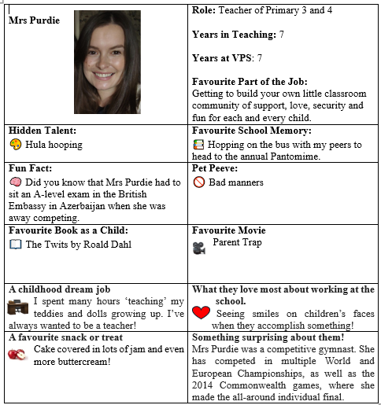
Don’t Forget!
School is closed to pupils for the half term break next week. When we return, we will hold our parent teacher appointments. School will close at 12.45pm for all pupils on those days.


17th – 19th Feb – parent / teacher appointments
20th February – KS2 class trips & PFA Pancake day
24th February – Netball club begins each Tuesday
25th February – Football club continues each Thursday

